**Task 1:- Setup a local database, create a table, insert some records using any database client**

CREATE DATABASE DB;

use DB;

create table db.users(

id int NOT NULL AUTO_INCREMENT primary key);

insert into db.users values(1),(2),(3);

select * from db.users;

OUTPUT:-

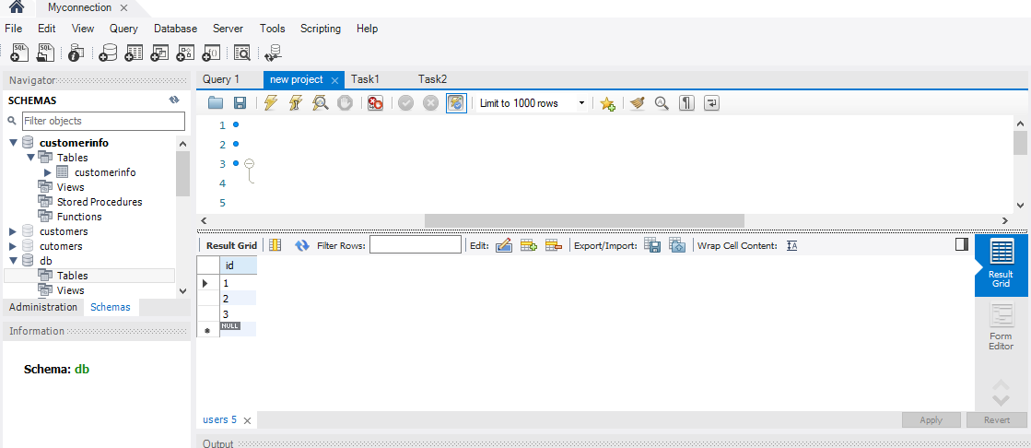

**Task2:- Write SQL to insert and retrieve records from the above table using the same database client**

insert into db.users values(4),(5),(6);

select * from db.users;

OUTPUT:- 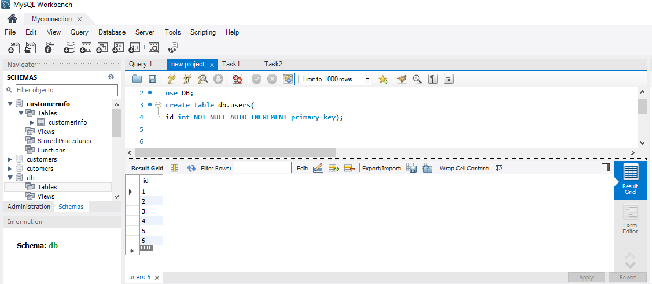

**Task 3:- Write java code to insert and retrieve the records from the database table.**

import java.sql.Connection;

import java.sql.DriverManager;

import java.sql.ResultSet;

import java.sql.Statement;

public class mysql {

public static void main(String[] args) {

try {

Class.forName("com.mysql.cj.jdbc.Driver");

Connectio con=DriverManager.getConnection("jdbc:mysql://localhost:3306

/DB", "root","Sonali@1996");

Statement stmt = con.createStatement();

System.out.println("Inserting records");

String sql = "INSERT INTO users values (13)";

stmt.executeUpdate(sql);

sql = "INSERT INTO users values (14 )";

stmt.executeUpdate(sql);

sql = "INSERT INTO users values (15 )";

stmt.executeUpdate(sql);

sql = "INSERT INTO users values (16 )";

stmt.executeUpdate(sql);

sql = "INSERT INTO users values (17)";

stmt.executeUpdate(sql);

System.out.println("Inserting records");

ResultSet rs = stmt.executeQuery("select * from users");

while(rs.next())

System.out.println(rs.getInt(1)+" ");

con.close();

}

catch(Exception e) {

System.out.println(e);

}

}

}

OUTPUT:-

